Migration from Linde Express to Lindedirect.com
All existing accounts on LindeExpress have accounts on Lindedirect.com with their historical information loaded to the new website for an easy transition.
Steps to help your customer migrate onto lindedirect.com:
- Visit lindedirect.com
  - The Username will be the email address they have associated with their express account
- Select Forgot password
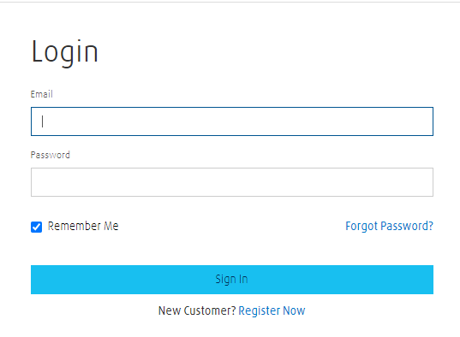
- They will be prompted with the below information and receive an email confirmation with the steps to reset their password.

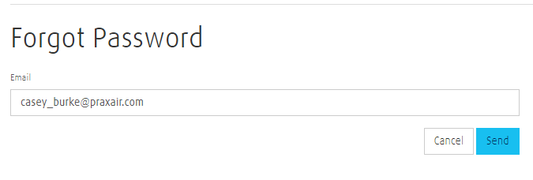
- Once they set their password – they will be able to use their username & password to log in to the website.

Tips/ FAQ’s on How to Navigate Lindedirect.com
- What are the benefits of my Lindedirect.com account?
- https://www.lindedirect.com/about-us/frequently-asked-questions/website-functionality/available-now/what-can-i-use-lindedirect-for-if-i-have-an-account

- How do I view and print my Invoices?
- https://www.lindedirect.com/about-us/frequently-asked-questions/website-functionality/available-now/how-do-i-view-and-print-invoice-detail

- How do I view and print my Proof of Delivery (POD)?
- https://www.lindedirect.com/about-us/frequently-asked-questions/website-functionality/available-now/how-can-i-access-invoices-and-proof-of-delivery-documents-for-a-specific-ship-to-account

- How do I switch between my accounts?
- https://www.lindedirect.com/about-us/frequently-asked-questions/website-functionality/available-now/how-do-i-switch-between-accounts

- How do I find my Shipto Account?
- https://www.lindedirect.com/about-us/frequently-asked-questions/website-functionality/available-now/what's-the-easiest-way-to-find-my-shipto-account

- How do I add a Nickname to a Shipto Account?
- https://www.lindedirect.com/about-us/frequently-asked-questions/website-functionality/available-now/how-do-i-create-a-nickname-for-my-shipto-account

- How do I set up my Wallet?
- https://www.lindedirect.com/about-us/frequently-asked-questions/website-functionality/available-now/how-do-i-create-a-nickname-for-my-shipto-account

- What do the different inventory statuses mean?
- https://www.lindedirect.com/about-us/frequently-asked-questions/website-functionality/available-now/what-do-the-different-inventory-statuses-mean

- How do I place an order on my Account?
- https://www.lindedirect.com/about-us/frequently-asked-questions/website-functionality/available-now/how-do-i-place-an-order-(if-i-have-an-account)

- Are the product list’s I created on Express in Lindedirect.com?
- Yes – all product lists were migrated over with the account details. Once the user is logged in they will select My Lists in the top navigation.

- Once on the Product List page – select the drop-down to see all previously created product lists.
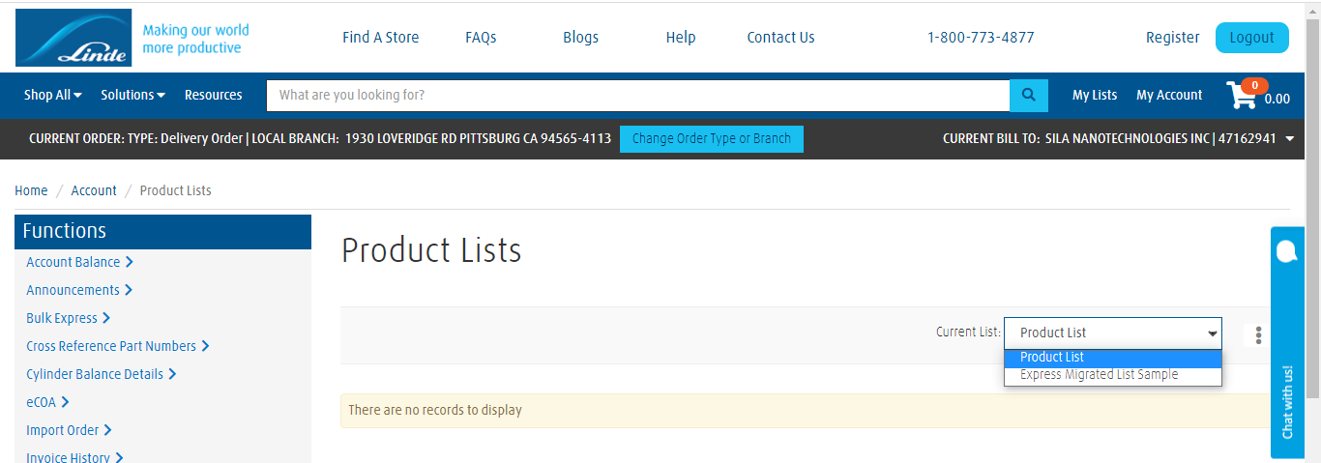

If you or your customer has any issues or questions, please reach out to lindedirect@linde.com

