ORDER RETURNS
You may create a return request online by following these steps:
• Open Orders page to view orders.
• Click on the desired Order Number to place a return.
• Click on ‘Return Order’ from the Order Detail page.
• Select the item or items you want to return, select a reason from the drop-down list, and click ‘Return Selected.’
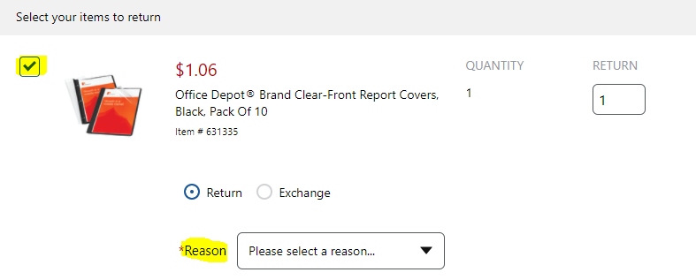
• Review the information for the return and click ‘Submit Return’ at which point you will get a Return Authorization Number for the return.
• Your return will be pickup by internal campus delivery the next business day and returned to Office Depot.
• You may return most items in their original packaging within 30 days (most technology items within 14 days). If possible, all returns should be in their original packaging.
• You may submit only one online return request per order. Please contact Customer Service at 800-279-1528 if you need to return an additional item from the same order.

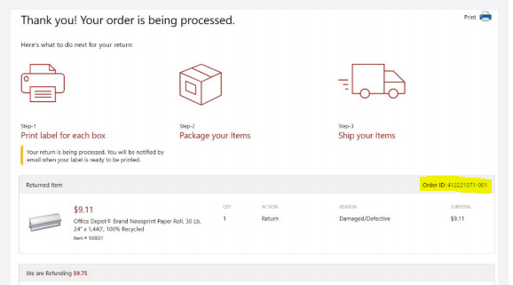
Please Note | If a return has already been placed on an order, the ‘Submit Return’ button will not be available

