ePro (eVouchers & Purchase Requisitions) Universal Workflow – November 1, 2022

- Here is the box that will pop up when you send to workflow. The MFK with the largest amount will determine routing. Select the workflow route based on the MFK Org, department and sub-department. Please see the yellow highlight below. Verify this is the right routing based on your knowledge. If it is not, click the Change Sub Department button.

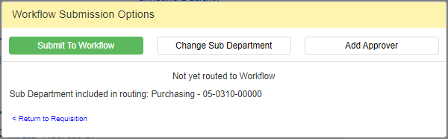

- The Workflow widget will display at the bottom of the evoucher and purchase requisition for approvers to Approve Package, Void Package or Add Approver.
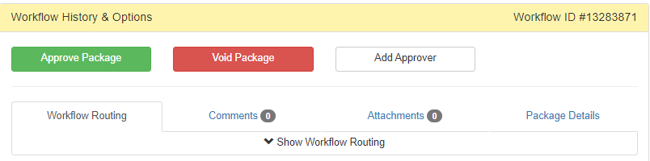

- For more details on Universal Workflow, please use the HELP in University Workflow-within Self Service or Chris Leichty at chris-leichty@uiowa.edu or 319-335-0384.
